SmartPlant 3D Piping v7
User Training Exercises

Table of Contents

LAB-1: Setting Default Properties 5
LAB-2: Basic Routing 6
LAB-3: Basic Routing - Using Angle Control and the Length Control tools 11
LAB-4: Basic Routing - Using PinPoint and Plane Control 13
LAB-5: Routing To or From Equipment Nozzle 15
Lab-6: Routing To or From Existing Pipe Runs 17
Lab-7: Routing To or From Straight Features 19
Lab-8: Placing Inline Components 20
Lab-9: Control Valve Station 21
Lab-10: Insert Tangential Branch 22
Lab-11: Editing Pipe Run properties 23
Lab-12: Route Pipe Runs with SmartSketch & PinPoint Tools 24
Lab-13: Placing Instrument and Engineering Items 29
Lab-14: Sloped Pipe Runs – Degree Slope 31
Lab-15: Sloped Pipe Runs – Fraction Slope 33
Lab-16: Routing Flanged Pipes (Optional) 35
Lab-17: Placing Instruments on the fly (Optional) 38
Lab-18: Placing Taps 39
Lab-19: Advanced Routing 41
Lab-20: Routing with Specialty Components and Pipe Splits 44
Lab-21: Routing Using Spherical Coordinates 47
Lab-22: Routing Using Cardinal Points 48
Lab-23: Attribute Break 49
Lab-24: Spools 50
Lab-25: Sequence Objects 51
Lab-26: Routing Using P&ID 52
Lab-27: Pipe Supports 58
Lab-28: Reports 60
Lab-29: Interactive Clash Detection 61

LAB-1: Setting Default Properties
- Open a Session file with Imperial Units and define Workspace to Display U04 and U04 CS
- Select Task -> Piping
- Make sure the Active Permission Group is set to Piping
Note: Objects that you place directly in the model are assigned to the active permission group. Therefore, you are responsible of making sure the objects are assigned to the appropriate Permission Group.

- Change the locate filter to All
- Expand Workspace explorer and select Process under, A2 > U04
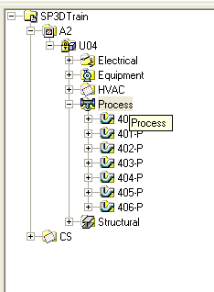
- Open properties page for Process system (right click > properties)
- From System Properties options, Switch to Default Properties Value Tab
- Under Standard category, Set Specification to 1C0031
- Change the Category to Temperature and Pressure
- Define following Values
Design Max Temperature: 100F (System will/might change the units to match units specified under Tools > Option, units tab)
Design Max Pressure: 125PSI (System will/might change the units to match units specified under Tools > Option, units tab)
- OK on the form
- Save session file

LAB-2: Basic Routing
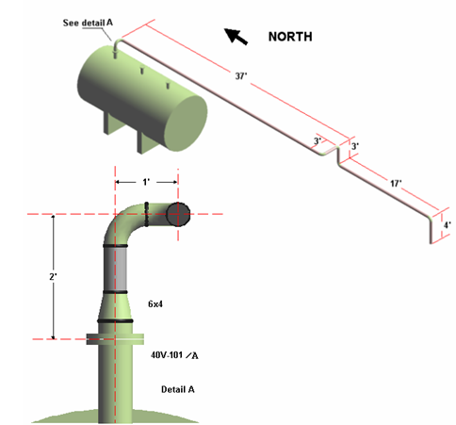
- Select Route Pipe command
- Select nozzle 40V-101/A as the starting point
Hint: To locate item, set the locate filter pulldown to Equipment and enter 40V-101 in the Workspace Explorer key-in field and press enter. The equipment highlights on the Workspace explorer and the view, select the Fit command to center the view(s) on this equipment item. Holding Shift-A as you click the Fit command will fit item in all available views.
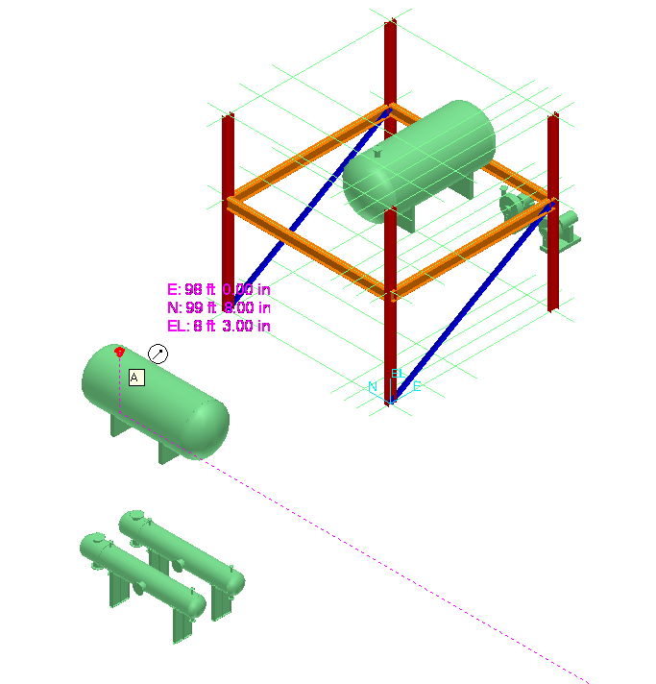
Note: in the next step you will be selecting a Pipeline System where the piping you are about to route will be stored/located. The Pipeline System is not just a hierarchy container object, but also dictates what Specifications / defaults are available for routing.
- The system opens the Create Pipe Run Dialog box. Select &More in the Pipeline property field to open the Select System dialog box.
- Navigate the system folder hierarchy and select 400-P pipeline system.
- Software fills the specification defined at the parent system level ( Defined in Lab1)
- Fill the following properties:
Specification = 1C0031
Nominal Diameter = 4 inch
Flow Direction = UpStream
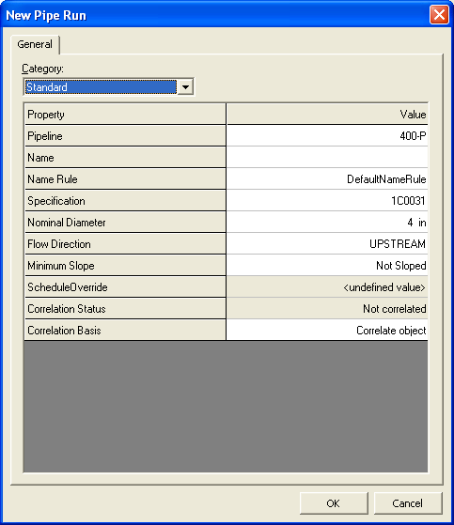
- Switch to Temperature and Pressure Category
- Verify that software has transferred Temperature and Pressure from parent system
- OK on the form
Note: The OK button returns you to the dynamic graphic display
- Go to the Pipe Route ribbon bar and key in 2ft in the length box
Recall that the length box values of 2ft will constrain the length of pipe to that value.
- Position the cursor above the nozzle until the system returns the SmartSketch U-axis aligned indicator as shown
Recall: This glyph is your key to knowing that your projection for the routing of the pipe is going in the vertical direction.
- Left mouse click to accept the endpoint.
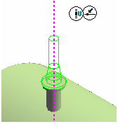
- Go to the Pipe Route ribbon bar and key in 1 ft in the length box.
- Position the cursor in the Easting direction until the system returns the SmartSketch E-axis aligned indicator.
- Left mouse click to accept the endpoint.
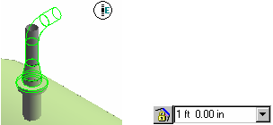

- Go to the Pipe Route ribbon bar and key in 37‘ in the length box.
- Position the cursor in the South direction until the system returns the SmartSketch N-axis aligned indicator. Left mouse click to accept the endpoint.
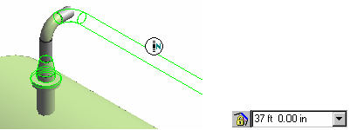
- Go to the Pipe Route ribbon bar and key in 3’ in the length box.
- Position the cursor in the Easting direction until the system returns the SmartSketch axis aligned indicator. Left mouse click to accept the endpoint.
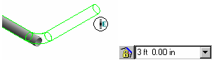
- Keep 3’ in the length box.
- Position the cursor down until the system returns the SmartSketch U-axis aligned indicator.
- Left mouse click to accept the endpoint.
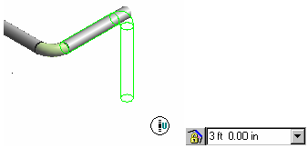
- Go to the Pipe Route ribbon bar and key in 17’ in the length box.
- Position the cursor in the South direction until the system returns the SmartSketch N-axis aligned indicator.
- Left mouse click to accept the endpoint.
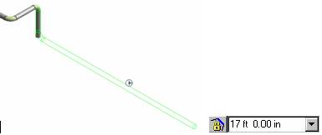
- Go to the Pipe Route ribbon bar and key in 4’ in the length box.
- Position the cursor down until the system returns the SmartSketch U-axis aligned indicator.
- Left mouse click to accept the endpoint.
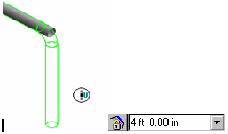
- Right mouse click to terminate the Pipe Route command.
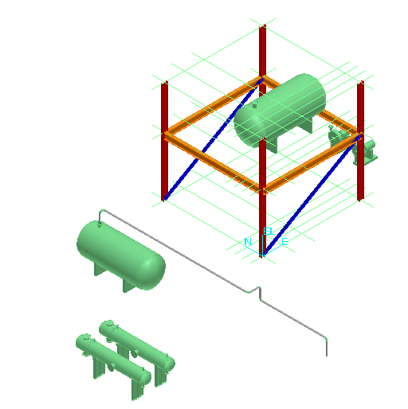

LAB-3: Basic Routing - Using Angle Control and the Length Control tools
Route pipeline 401-P from the equipment/nozzle 40E-101A/E1 to its completion. Refer to the sketch below for detailed information.
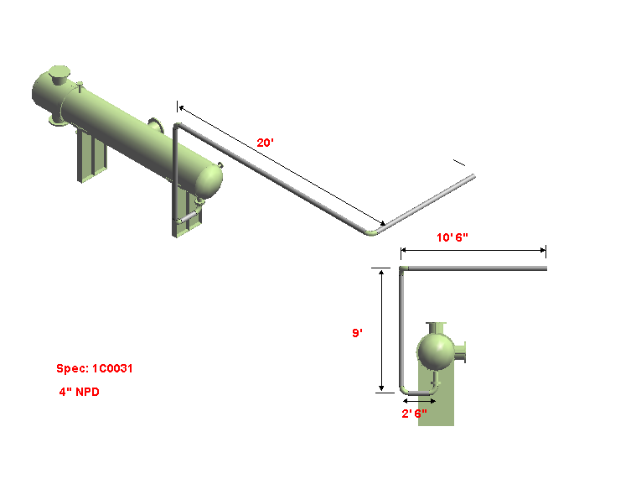
N
Note: Details steps are not given for this lab.
- Start Route Pipe command, select nozzle E1 as the starting point
- Define Run properties and select line number 401-P, OK on the form
Note: When connected to component, software automatically locks the angle to keep the line straight. In this case, angle is locked at 0. Change angle to 90
- Key in length lock 2’ 6”, move cursor West of nozzle, click when E glyph is shown
- Rote up 9’, south 20’ and east 10’6”.
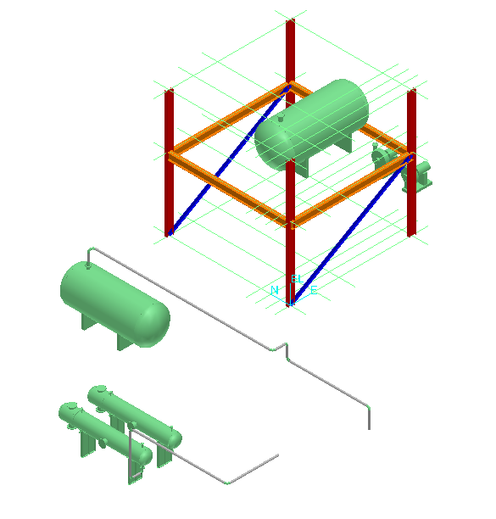

LAB-4: Basic Routing - Using PinPoint and Plane Control
Route pipeline 402-P from the equipment/nozzle 40E-101A/E2 to its completion using PinPoint, Relative Tracking, Working Plane Control, Angle Control and the Length
Refer to the sketch below for detailed information.

Hint: Use Insert Component or Insert Split command to place.

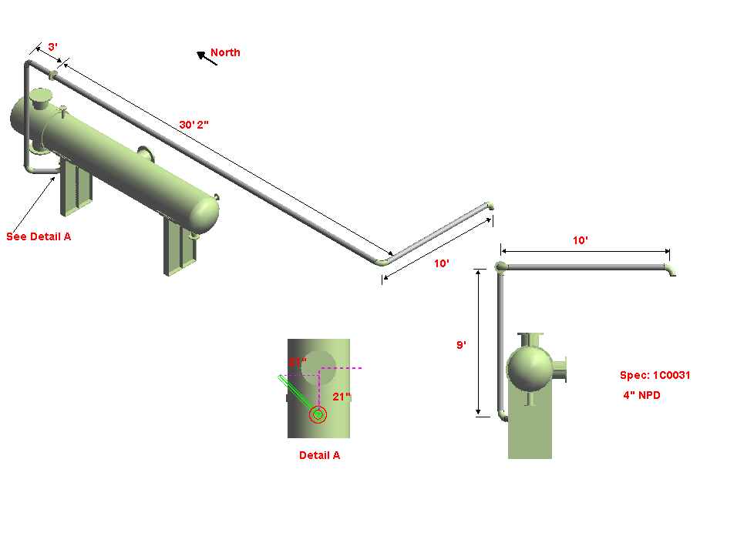
Nozzle E2

- Activate Pinpoint if not already active
- Turn Relative tracking on ( or reposition target to nozzle)
- Start Route Pipe command, select nozzle as starting point
(verify that target moves there and you see 0,0,0 on screen)
- Define Run properties and select line number 402-P, OK the form
Note: When connected to component, software automatically locks the angle to keep the line straight. In this case, angle is locked at 0, unlock the angle.
- Set view orientation to Top/Plan
- Lock the active plane to Plan Plane 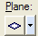
- Select F6 (Easting) key and key in -21” (in the pinpoint toolbar)
- Select the F7 (Northing) key and enter 21”
- Unlock the active plane
- Lock the angle at 90deg and set the pipe length to 9’. Place the next run on the U axis
- Place the rest of the runs (33’ 2” S and 10’ E)
- Upon learning the insert split command, return and insert the flanges at 3’ shown
- Upon learning the insert component command, return and insert an elbow by origin at the end of the last run as shown
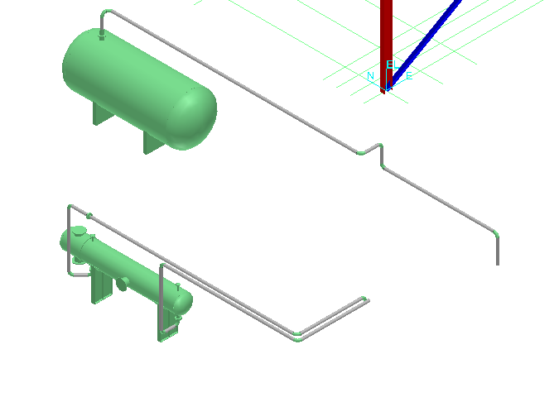
LAB-5: Routing To or From Equipment Nozzle
Route 12” NPD pipeline 403-P from the equipment/nozzle 40E-101A/C to equipment/nozzle 40E-101B/D using PinPoint, Working Plane Control and Angle Control tools (Use Fitting to Fitting makeup for the first 2 elbows). Attempt to complete this first without reading the steps below.
North

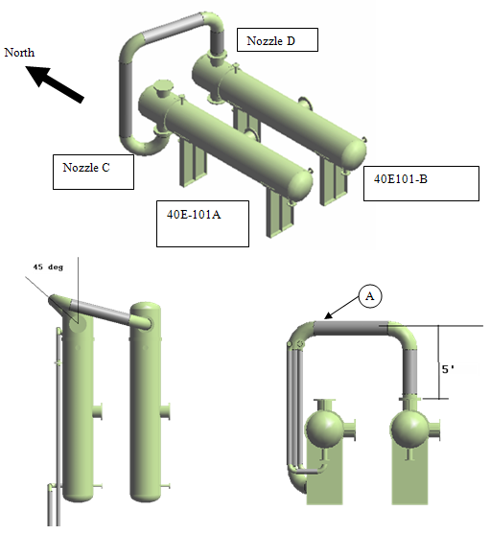

Hints:
1) Fitting to Fitting placement:
Start with the insert component command at nozzle C.
System opens the new pipe run dialog box.
Select Pipeline name 403-P
The NPD should already be correct from the nozzle data
Hit OK to close the piperun dialog box.
Select short code “Flange” and hit finish
Select “90 deg Direction Change”
Rotate the elbow by key in 135 deg
Hit Finish to place the elbow
Select “90deg Direction Change”
Hit finish to place the second elbow.
Select the Route Pipe command to switch to route.

2) Pinpoint tool and control plane
Use Pinpoint and relocate the target at the nozzle D.
Make sure the plane control is set to NO PLANE and key in 5’ in the EL pinpoint.

3) Smartsketch service
Use Smartsketch to make the straight feature (SF) straight up
Left mouse click to commit the SF.
Lock the plane control to PLAN and move the mouse over the nozzle D.
Left mouse click to place the next pipe. Its end point is now directly above nozzle D
Unlock the Plan Plane and select the nozzle D again to finish routing into the nozzle

Lab-6: Routing To or From Existing Pipe Runs

Route 10” NPD pipeline 404-P from the Pump 41P-101A/Suction to Storage Tank 41V-101/Noz2 using Working Plane Control, Angle Control, Pinpoint and the Length Control tools. Refer to the sketch below for detailed information. Attempt to complete this first without reading the steps below.
(Eccentric Size Change – Flat On Top)
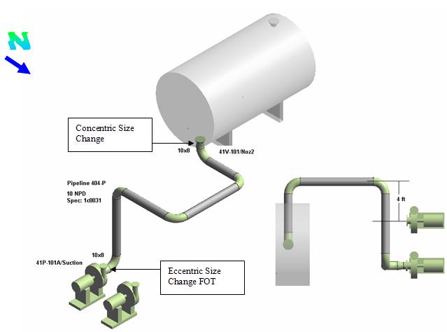
Hints:
1) Inserting the Concentric Reducer on the Tank
Start the Insert Component command and pick nozzle Noz2
Verify spec is 1C0031, flow direction is DOWNSTREAM and set Nom Diameter to 10in, then OK
Select the “90 Degree Direction Change” from the menu, set Angle to 90 deg and select Finish. The piping task will place the flange, concentric reducer and elbow
Before anything else, take note of the Run number in the ribbon bar, it’ll be needed shortly: ___________________
2 ) Next, place an eccentric reducer on the pump nozzle.
Start the Insert Component command and pick nozzle 41P-101A/Suction
Verify spec is 1C0031, flow direction is UPSTREAM and Nom Diameter is 8in, then OK (Eccentric reducers are not automatic, so it will be required to build the assembly component by component)
Select the short code “Flange” and Finish
Select the short code “Eccentric Size Change”. Then from the pull down menu for Runs, select the Run number from step 1 above. This ensures that these and the parts from part 1 above will all be treated as one single pipe run
Rotate reducer 180deg so that the flat side is at the top, then Finish
Select the “90 Degree Direction Change” from the menu and select Finish
Right after the elbow places, click on the Route Piping command (twice: first click exits insert component mode; second activates route pipe without disconnecting you from the end feature of the elbow)
3) Route between
While in Route mode and angle locked at 0deg, click on the elbow end placed in step 1 above to get the elevation to route up to
Reposition the Pinpoint target to Pump 41P-101B/Suction Nozzle
Make sure Angle lock is set to 90deg. Set Pinpoint North 4’ and place the Straight pipe making sure the E glyph indicator is shown
Point the pipe in North direction, angle is locked at 90, click on the tank’s elbow free end
Click on the tank’s elbow free end again to complete the pipe run. Make sure the end point glyph appears by the elbow’s end before you click to connect

Lab-7: Routing To or From Straight Features
Create the branch line by routing a 10” Pipe Run from the Pump 41P-101B/Suction to the Pipeline 404-P using Working Plane Control and Angle Control tools.
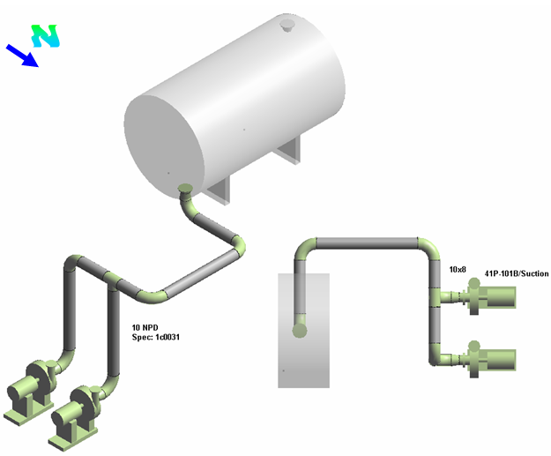
Hints:
Start routing at the pump using the insert component command and place the flange + eccentric reducer + 90 elbow
Switch to route pipe command and branch the line into the header.
Note: The pipeline number 404-P can remain the same, but this branch’s pipe run number must not be the same as the line it connects to

Lab-8: Placing Inline Components
Insert 150# Flanged Gate Valves into the Pump suction line 404-P. Refer to the sketch below for detailed information (Valves won’t look as detailed as those shown).

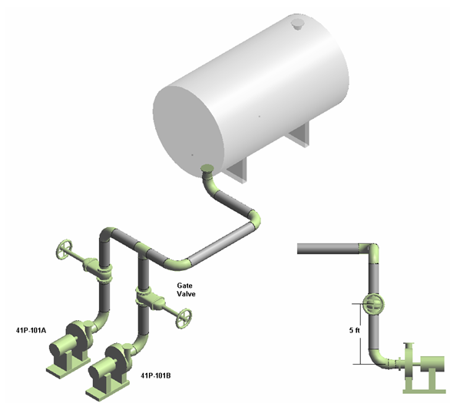

Hints:

Use Pinpoint or Point Along command to locate the placement point on pipe prior to starting the Insert Component command

Lab-9: Control Valve Station

Continue routing the pipeline 402-P using the commands learned. Refer to the sketch below for detailed information.

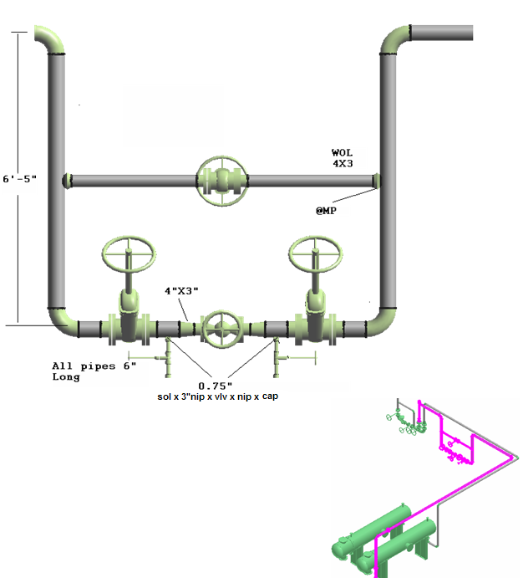

Lab-10: Insert Tangential Branch

Use the Insert Component command to insert a 1-1/2” tangential branch on line 404-P, at 12” from pipe end, near either suction port.

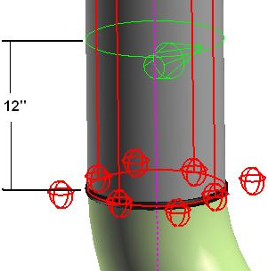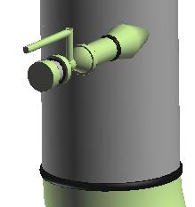

Hints:
Set locate filter to Pipelines and use the Workspace Explorer key-in field to enter line number 404-P and locate.
Use PinPoint to locate the point on pipe. Set the Target point at the base of the pipe and lock the elevation at 12 inches.
Select <New Pipe Run> from the Run menu to be able to select the new branch size.

Lab-11: Editing Pipe Run properties
Define the Insulation for the bypass in pipeline 402-P using the commands learned in this section. Refer to the sketch below for detailed information.

Select the bypass run of the Control Valve and key in the following information:

Insulation Specification: User Defined
Insulation Purpose: Heat Conservation
Insulation Material: Calcium Silicate (CS)
Insulation Thickness: 3 inches
Insulation Temperature: 200 F.

Create a Surface Style Rule to display the insulation graphic with transparent green style.

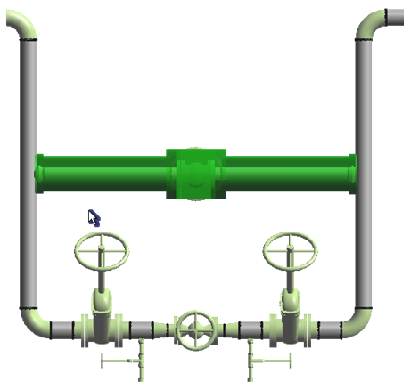

Lab-12: Route Pipe Runs with SmartSketch & PinPoint Tools

Route two Pipelines 300-W and 301-W from the Pump P-101/Suction nozzle to the Top of the Tower using the tools learned in this section. Refer to the sketch below for detailed information.

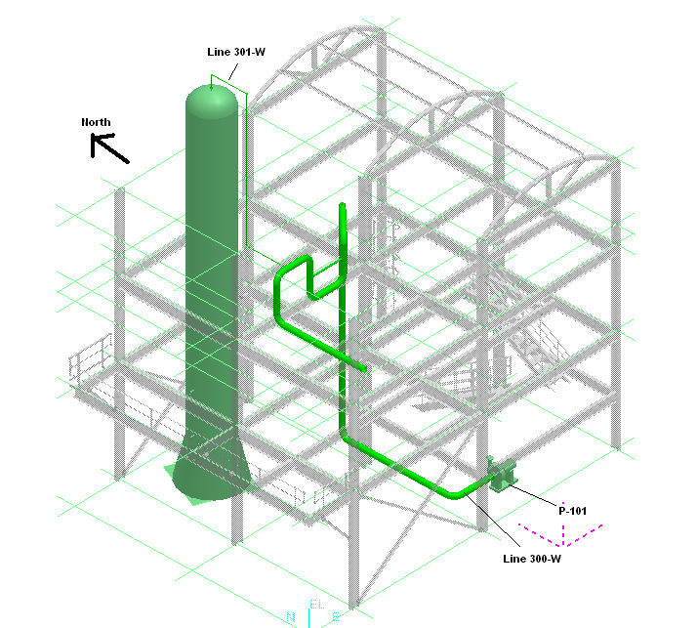
Go to the Piping Task. Make sure the Active Permission Group is set to Piping.
Start route from the suction nozzle using the following parameters:
Spec 1C0031
Pipeline 300-W
Hint: Start with Insert Component to place flange and eccentric reducer as seen below, then switch to Route Pipe to model the rest
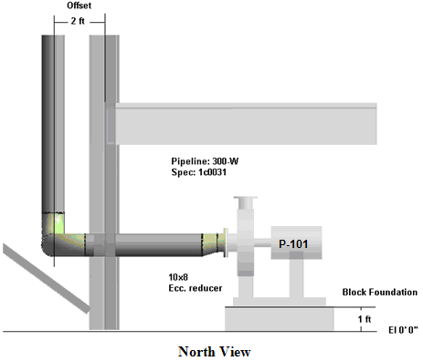

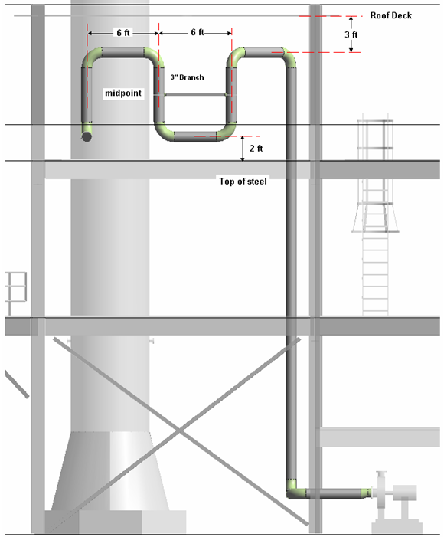
North View
Hint: Use Pinpoint Spherical Coordinates feature to route by distance (7ft) and direction (SW 45)
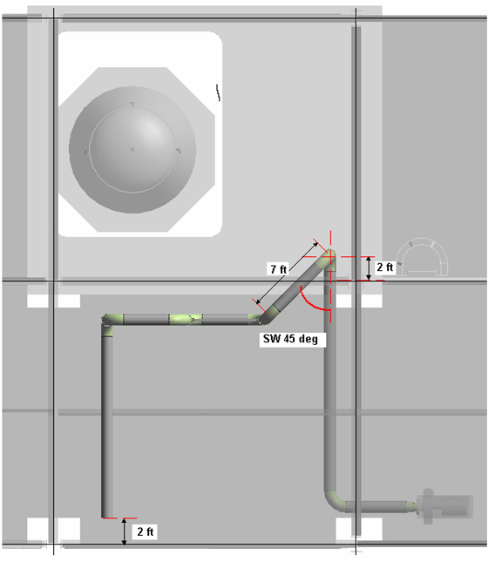

Top View

Start route from the Tower (T-101/ Nozzle C) using the following parameters:
Spec 1C0031
Pipeline 301-W

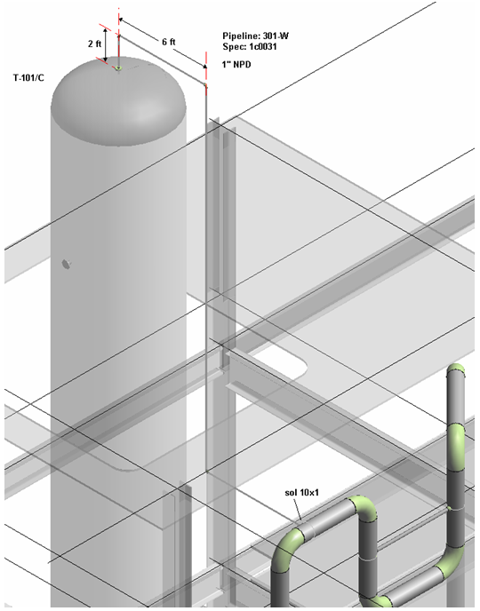

Iso View

Lab-13: Placing Instrument and Engineering Items

Insert valves along the pipeline 300-W. Refer to the sketch below for detailed information.

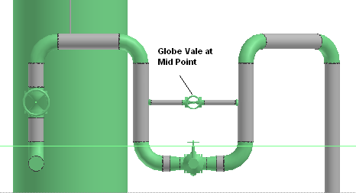

Instrument Details: Gate Valve Class 150 Gear Operated Mounted at variable angles
Part Class: CIGateVGearA4
Port 1 and Port 2 Details:
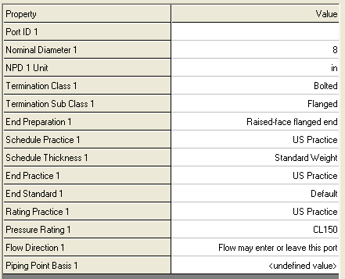
Note: The 8in nominal diameter will cause SmartPlant to automatically generate the concentric reducers. The Flanged termination types will cause SmartPlant to automatically generate the flanges at both ends. The valve, flanges and reducers become parts of one feature.

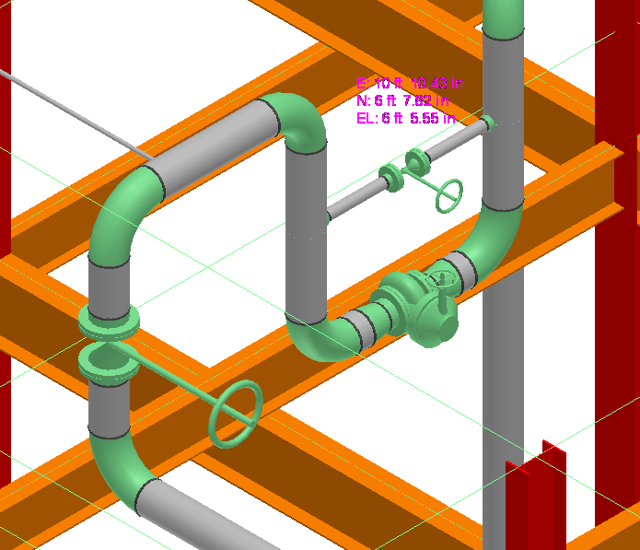

Lab-14: Sloped Pipe Runs – Degree Slope
Route a Pipeline 302-W from the Tower T-101/Nozzle D1 using the tools learned in this section. Refer to the sketch below for detailed information.
Start route from the Tower T-101/nozzle D1 using the following parameters:
Spec 1C0031
Pipeline 302-W
Slope enabled
Run slope down 2 deg

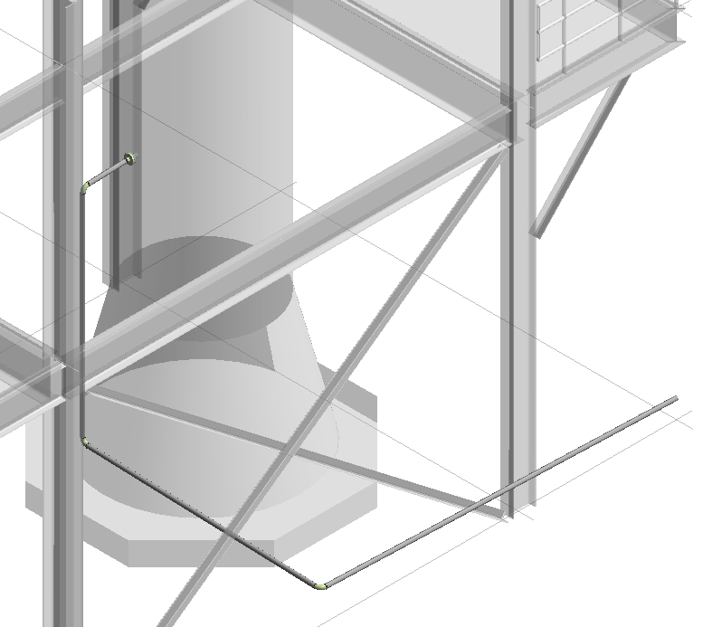
Iso View

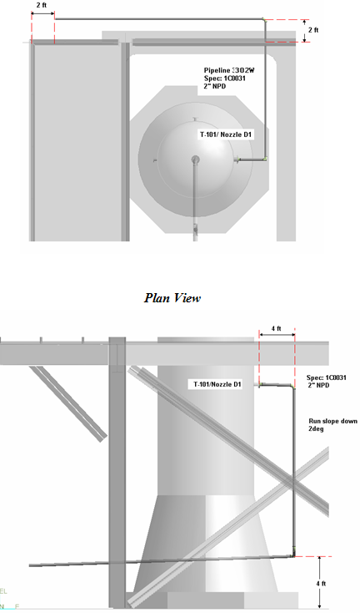
Hint: Remember to turn off the active slope when routing a vertical leg
Elevation View

Lab-15: Sloped Pipe Runs – Fraction Slope
Route Pipeline 2001-P (U02) from TA-101/STNoz1 to DR-100/N1 using the tools learned in this section. Refer to the sketch below for detailed information.

Start route from the TA-101/STNoz1 using the following parameters:
Spec 1C0031
Pipeline 2001-P
Size 6”
Slope:1/16” per 1’
Run slope down

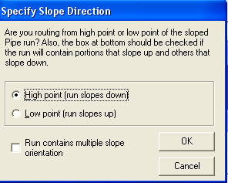

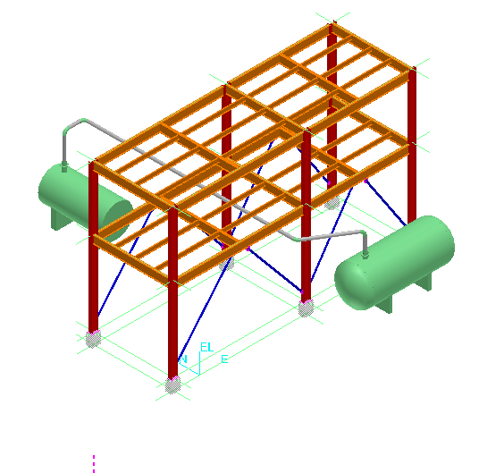

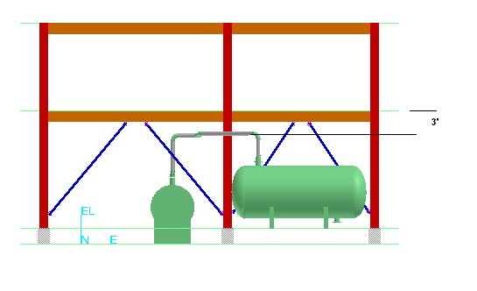

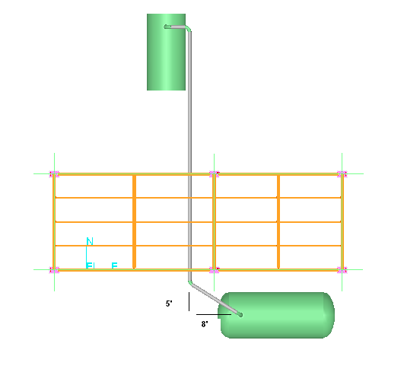

Lab-16: Routing Flanged Pipes (Optional)

Route pipeline U02, 2002-P from the equipment/nozzle TA-101/StNoz2 to its completion using PinPoint, Working Plane Control, Angle Control and the Length Control tools learned in this section. Refer to the sketch below for detailed information. Notice the system uses the preferred pipe length defined in the reference data. Make sure the Active Permission Group is set to Piping.

Use the following piping specification:

Pipeline: 2002-P
Pipe Spec: 1C0101
NPD: 8 in
Flow Direction: DownStream
Minimum Slope: Not Sloped

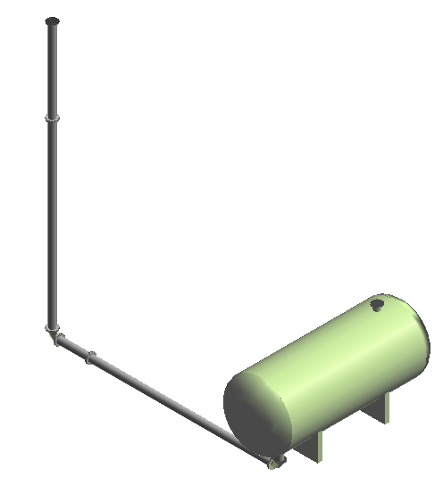
Isometric View of the pipeline 2002-P

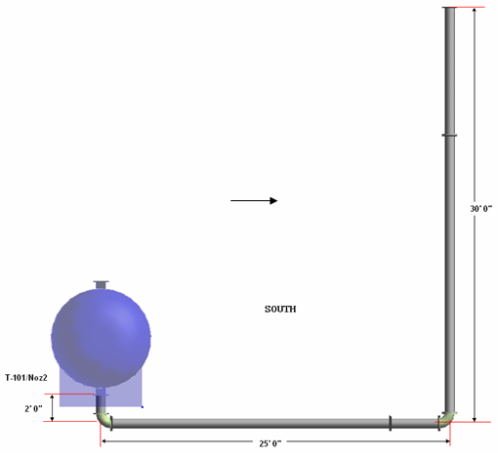

Section View of the pipeline 2002-P

Use the insert component and the route pipe commands to continue building the piping arrangement as shown below:

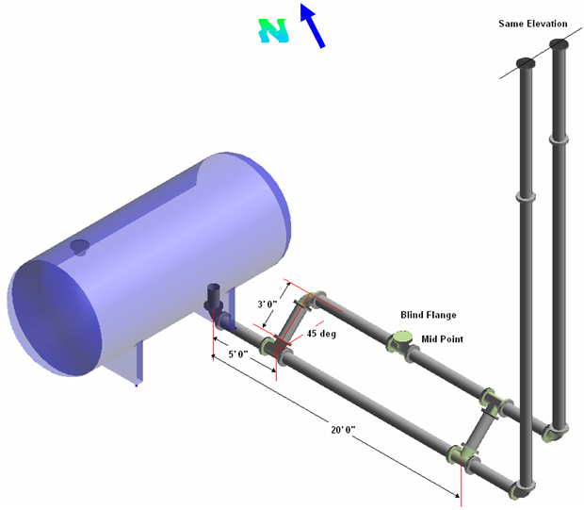

Isometric View of the pipeline 2002-P

Lab-17: Placing Instruments on the fly (Optional)

Insert Instruments on the fly into the lines 2002-P. Refer to the sketch below for detailed information.

Instrument Class Part Number
Piston Actuator Valve ISSPS4
Double Acting Fail Open Actuator Valve IPSR44

Use the insert component command to insert the instruments in the piping arrangement as shown below:
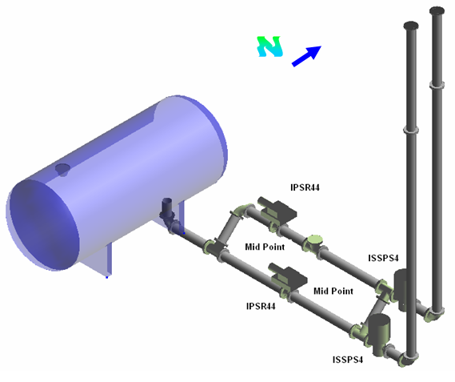

Isometric View of the pipeline 2002-P

Lab-18: Placing Taps

After completing this lab, you will be able to:

- Use the Place Tap Command.

Insert a Tap at the elbow of the 300-W pipeline as shown below with the following parameters.

Select the tap port to route a pipe in order to support the pipe run.

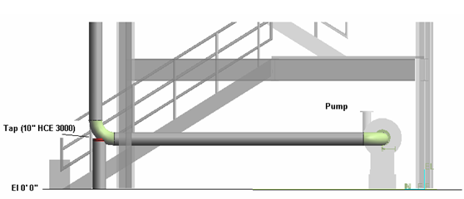
East View

Insert a Tap at the Eccentric Reducer of the 300-W pipeline as shown below with the following parameters.

Select the tap port to insert a nipple and then an instrument root valve.

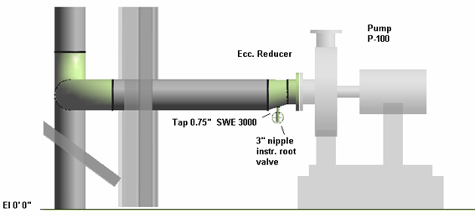

Lab-19: Advanced Routing

Continue Pipeline 400-P as shown and connect it to Pipeline 401-P

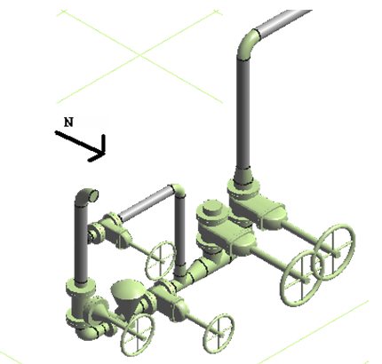

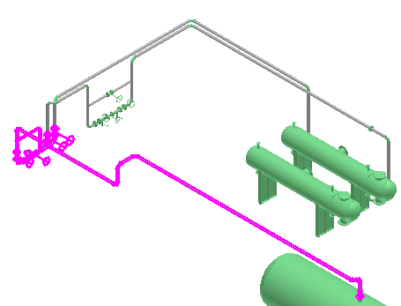

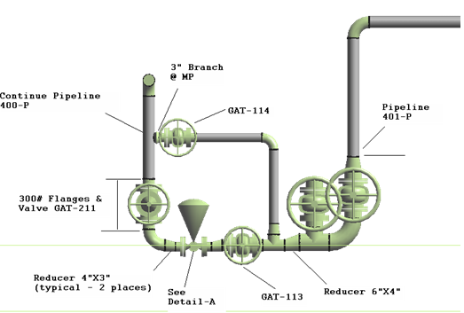

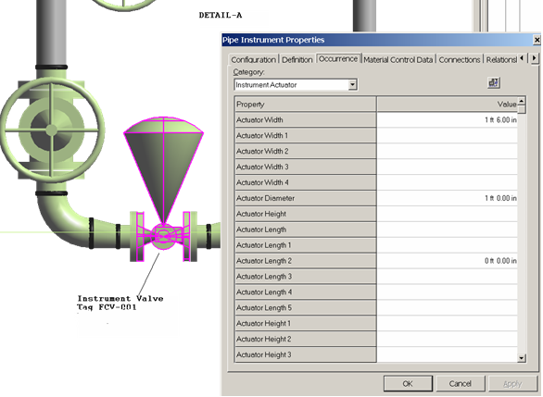
Instrument Valve: Valve with Rotary Diaphragm Actuator Position A 1

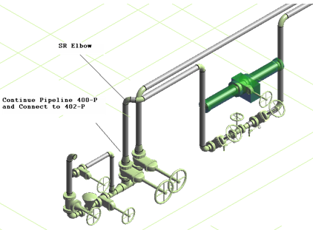

Lab-20: Routing with Specialty Components and Pipe Splits

Route Pipeline 2003-P (U02), from PU2-02, Line 2004-P From PU2-01 to VS-102

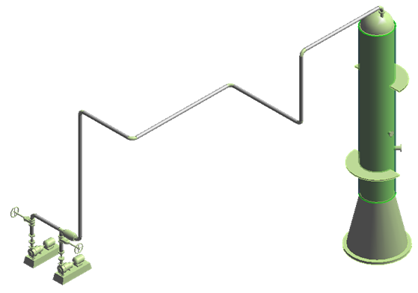

Spec: 1C0031
NPD: 6”

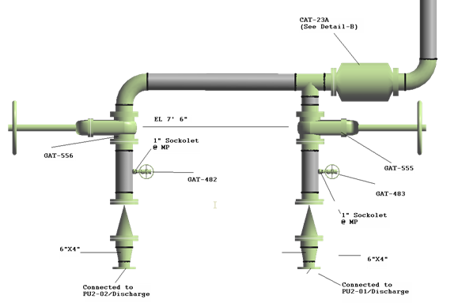

Piping Specialty Details: Detail – B

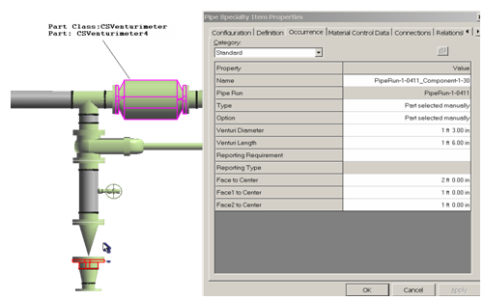
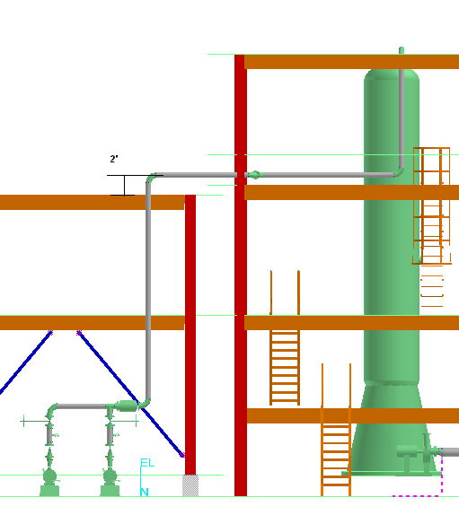

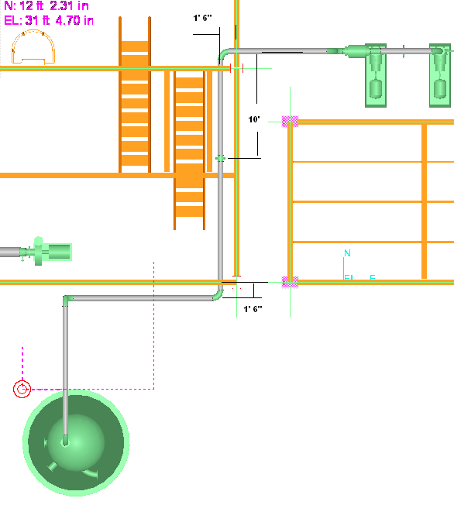

Lab-21: Routing Using Spherical Coordinates

Route Pipeline 303-W (Building-1), from P101 to VS-102
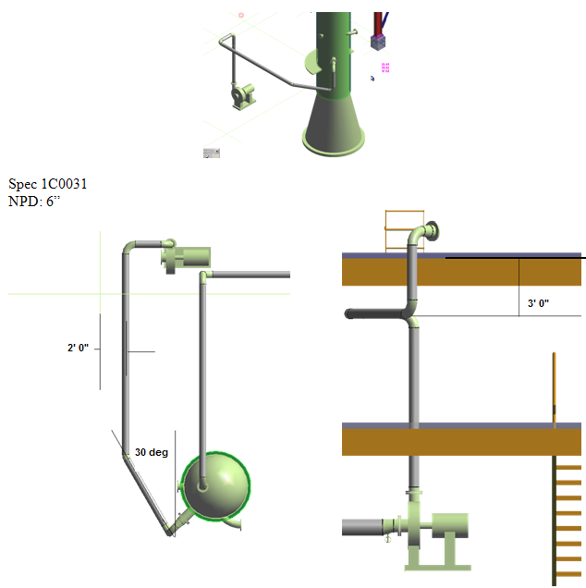

Hints: To find the location of the 45deg elbow, it helps to model part of the line from the pump up to roughly halfway the length of the pipe to be connected to the 45deg elbow. Then stop and start routing a line with the same piperun number from the vertical vessel out. Use the SmartSketch construction lines and spherical coordinates command to find the intersection for the two runs. The 45deg elbow will be automatic at the vertex where the two lines meet.

Lab-22: Routing Using Cardinal Points
Define a new pipeline system 2005-P in A2, U01 and route a piperun by top of pipe 6” off from bottom of steel as shown. Start routing from equipment E-102 nozzle N1 and finish it 2ft North from the last beam. Use spec 1C0031.
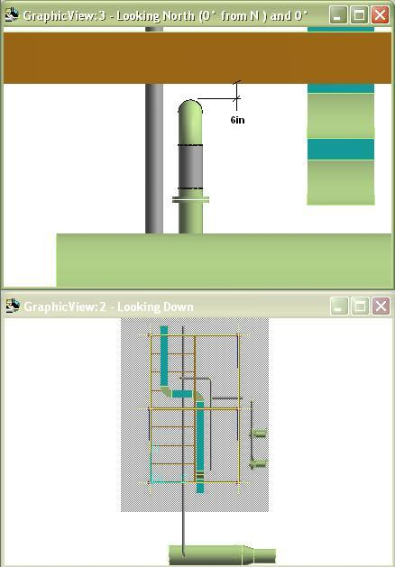
Hints:
In Workspace Explorer right click on “A2>U01>Process” to create new pipeline 2005-P.
Be sure to set SmartSketch “Edges on solids” option (Tools>Options) to on.
Use Set Offset command to define an External reference type at 6” from centerline to place the vertical run on E-W plane. Offsets are often more easily defined from orthogonal views. Next, before placing the 2005-P horizontal run, switch plane to Plan Plane and change the Offset reference type to Cardinal Point by top of pipe. WARNING: You may need to select the BOP or other cardinal point (trial-error) on the form to be able to route by TOP in the desired direction.

Lab-23: Attribute Break
Locate or route a 10ft+ long pipe run from any free vertical nozzle, then use the Insert Split command to add personnel protection insulation up 84” from the nozzle connection.
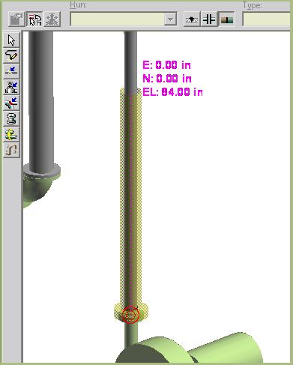
Hints:
Use pinpoint to locate the split point along pipe run.
Set the selection tool filter to Feature to select the split section of pipe and flange.
Use user defined insulation in the properties page to set Personnel Protection insulation.
Use Format>View to turn on the insulation on the views and Format>Surface Style Rules to change the display style to a translucent color, as learned in common apps class.
NPD Change
Locate the free end of pipeline 300-W. Use Route Pipe and <New Pipe Run> to change NPD to 8” and extend the line 4ft.
Use Route Pipe and <New Pipe Run> again to change NPD this time to 3”. Note as you extend the line that the system will automatically insert back to back reducers as defined per spec to accomplish the desired attribute change.
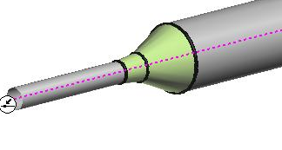

Lab-24: Spools
Start the Spool Generation command and locate pipeline 1003-P (A2, U02).
Accept the default Options as shown.

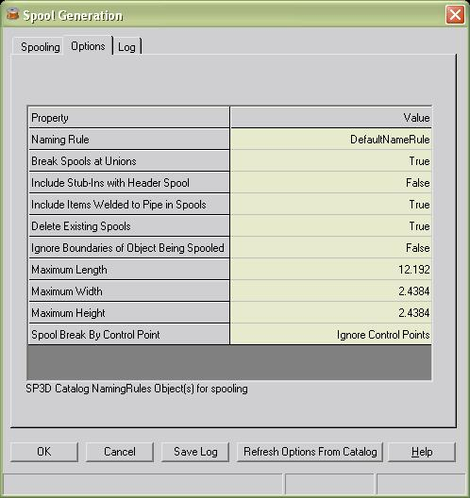

Review the new spools in the Log tab. Make sure the ToDoList is empty.
Locate line 1003-P, place Control Points (Insert>Control Point) at the joints shown below and re-run Spooling with Spool Break By Control Point option set to Break at Control Points. Go to the Log tab and click on the new spools to highlight them in the view.
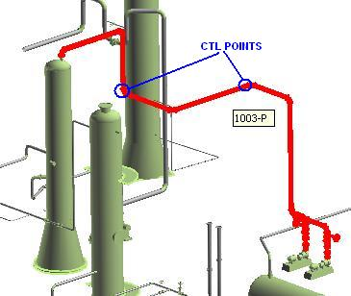
Hints:
This will only work when the Control Points are linked to Connection objects. If Welds or Features are used the spooling process will ignore the Control Points. Use the QuickPick tool to find Connection objects (look like spheres inside weld joints) at break points.

Lab-25: Sequence Objects
Set your selection tool to Welds and review a few welds’ ID on pipeline 1003-P.
Start the Sequence Objects command and run it on line 1003-P using the following parameters:
Review the same welds’ ID numbers. A new sequential value should appear

Lab-26: Routing Using P&ID
Route Pipeline using P&ID for line and component data

Define Appropriate filter for your workspace
Go to Smartplant > View P&ID
Select INT01 from the PID list, Select open button
PID Viewer opens up in a Window
Window to Nozzle A5

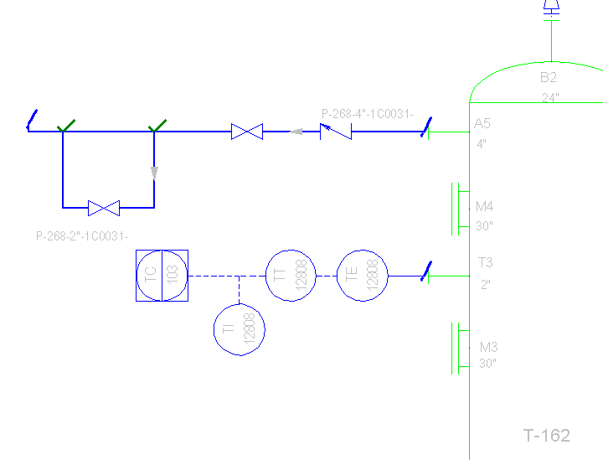

Select Route Pipe command.
Select T-162/A5 as starting point
System open up the New Pipe Run form with all the data already filled.

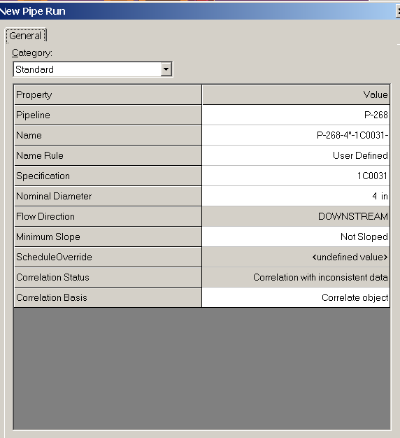

Ok on the form
Route West 5’, Rout to Elevation 21’, Route West 25’
Your Pipe Run should resemble this (only Tank and Pipe Run Shown – Rest of the objects are Hidden)
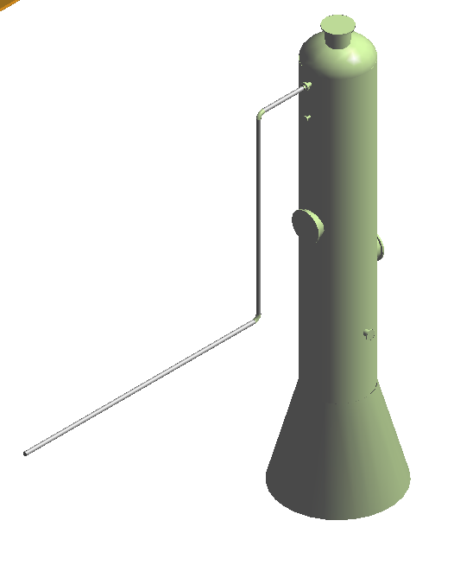
Select Route Pipe command. Define Starting point at 13’ East of free end of the Pipe Run placed above.
System Brings up the PI&D viewer. Select the BYPASS run from P&ID.
Software displays the New Pipe Run form with data already filled.
OK on the Form.
Route South 5’. Route West 8’. Connect to the Original Run to close Bypass.
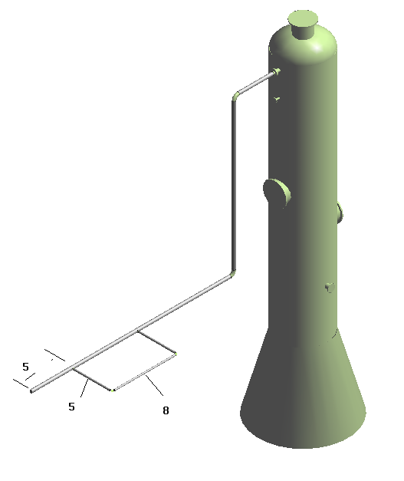

Select Insert Component Command
Select the Midpoint of East West Run on Bypass
Software Displays the P&ID viewer. Select the Valve from Bypass in the P&ID. Software will select the valve from Catalog and display it Dynamically in the model.
Locate the valve and select Finish.
Place other 2 valves in the same way.

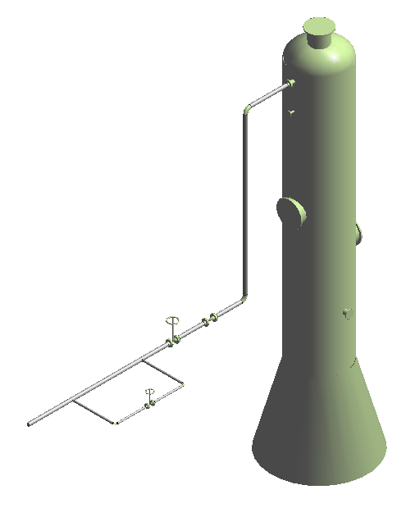

When components are placed, they will change color(green) in P&ID.
Change the locate filter to Pipe Runs. Select The Bypass run.
Select Framework, Compare Design Basis. Software shows the Data in the model and P&ID. Go to Topology Tab and review all the components on the run. Select Update. Select Close button.
This will change the run color to green in P&ID.
Update the data for Main Run Same way. When finished, Both Runs should turn green in P&ID.

Using P&ID viewer Route From T-162/B1 to Pump P-162/N1.
After Routing, Select Run and Compare Design Basis.
Then Route From P-162/N2, Route Up 10’, North 10, and east 15’.
Then Route the Bypass and Insert components. When finished run Compare Design Basis.

Your View Should Resemble This.

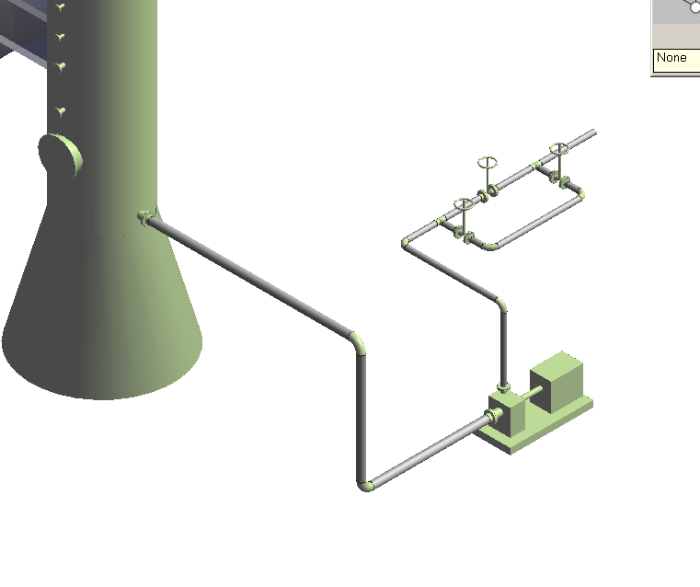

Optional: Place a 6X4 Reducer at the end of P-101-4”- and connect the Line to E-102/N2

Optional: Place a 6X4 Reducer at the end of P-268-4”-1C0031- and connect the Line to VS-102/N2

Lab-27: Pipe Supports
Add hangers to line 2005-P in A2 U01, at the three support beams shown below.
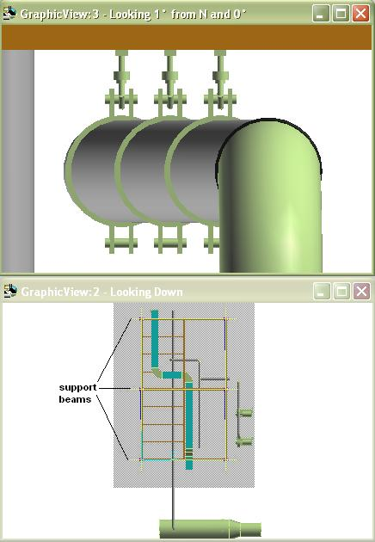
Hints:
Switch to Hangers and Supports task and follow these steps:
1. Click Place Support by Structure on the vertical toolbar.
2. Select the feature to support.
3. Click Accept (check mark on ribbon bar) .
4. Select the supporting structure to use.
5. Click Accept .
6. Select the support type.
Turn off the rule option
Select Type>more…
Navigate to HS Assembly>Rigid Rods>Assy_RR_SR_MD
Pick Assy_RR_SR_MD_2 and OK
7. Click Finish.
8. Select the next supporting beam
9. Click Accept.
10. Click Finish.
11. Repeat for the remaining beam
OPTIONAL
Route an 8” NPD piperun 3 FT above a structural beam.
Switch to Hangers and Supports task and follow these steps.
- Select Place Support by Structure
- Select the pipe above the beam and accept by selecting the green checkmark
- Select the beam below the pipe. Notice prompt at bottom left of window is being followed.
- System will display a tentative support selected by “Rule”. Notice the base location
- Use the placement location toggles to set the support to the left of pipe and attached to the top of beam

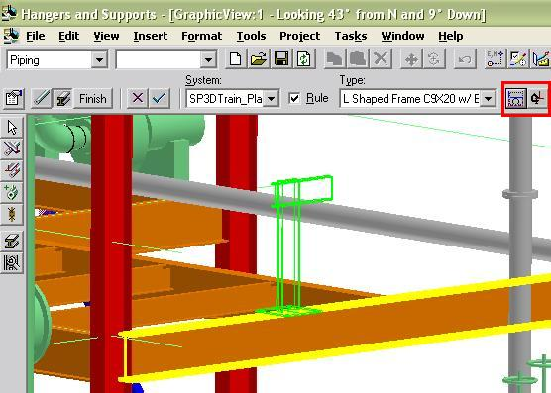

- Click Finish to complete placement.
- Return to the Piping Task
- Select the pipe with the support, then move it up 1FT. Make sure the support follows
- Move the same pipe down 7FT, (1+ ft below the beam). The support placement rule should adjust the type of support.
- If needed, in Supports Task toggle the point of support attachment to structure location to a lower flange
Place a U bolt on the 8” NPD piperun using the Place Part command in the Hangers and Supports task. Select the 8-inch from catalog menu option “Parts\Anvil\Pipe Clamps\Anvil_FIG137”. Follow the prompts and use pinpoint, function keys and rotate as needed to place the item as shown.
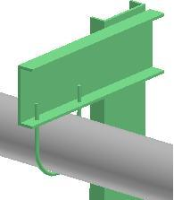

Lab-28: Reports
Extract a valve list from the model, sorted by NPD.
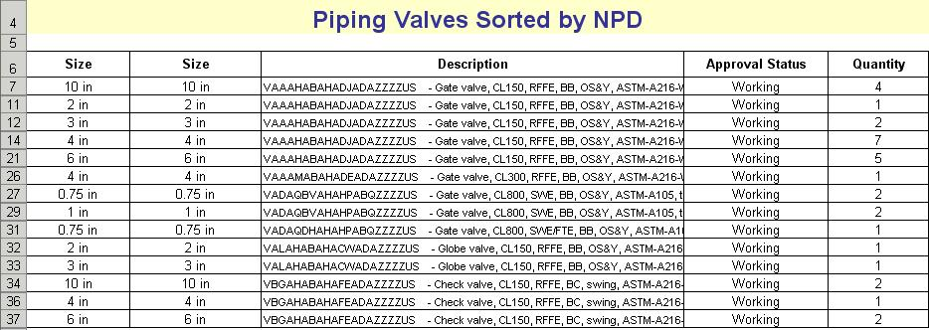
Extract a pipeline list, sorted by name.
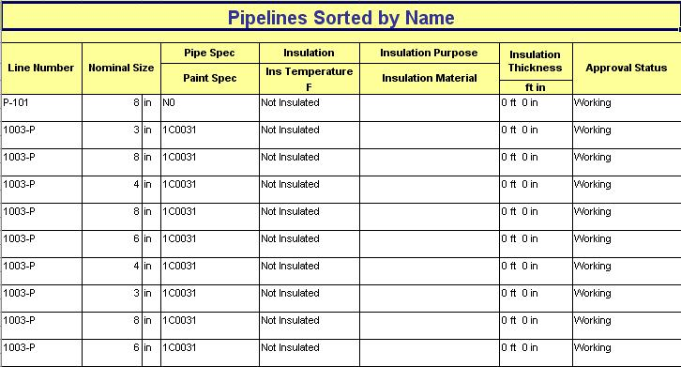

Hints:
In Piping Task, select Tools>Run Report to extract reports.
From the Run Report interface, select the Catalog Reports interface and navigate to the Piping report types to use standard delivered report formats.

Lab-29: Interactive Clash Detection
Activate Local Detect clash detection to highlight Simple Physical and Detailed Physical interferences during routing. Set the marker size to 2ft.

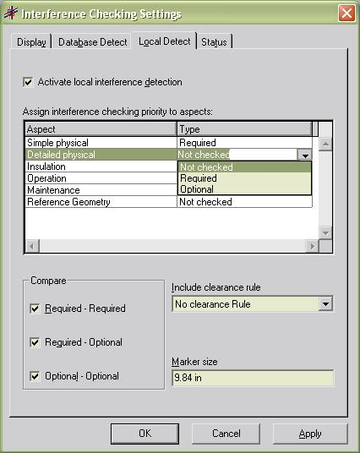

Route a 10” NPD pipe across any structural steel members as shown.
Notice the clash markers added by the system.

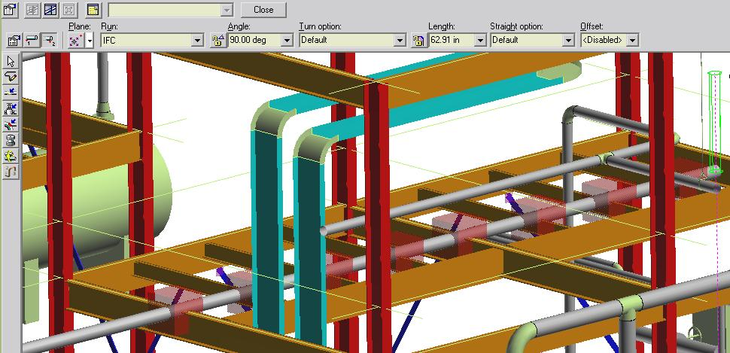

Hints:
Use Tools>Check Interference to activate detection. Select the Settings button on the ribbon bar that appears. Select the Local Detect tab to access and change the settings for local detection.
Notice the bottom right of the SP3D window, it will show the percent progress of “IFC” detection during modeling.

